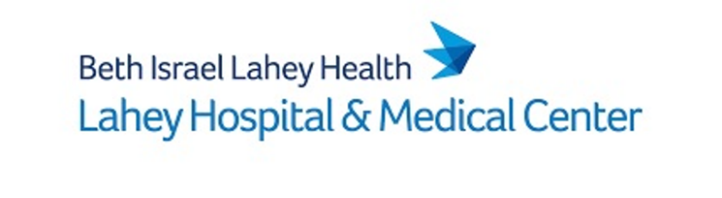
Join Massachusetts top Hospitals, 20 Minutes from Boston! Lahey’s Hospital Medicine Dept.
Lahey Hospital is part of BILH and located 20 minutes North of Boston. The Hospital Medicine Department is looking for an experienced AP (Nurse Practitioner/Physician Assistant) Hospitalist to join our Burlington or Beverly Campus. Hospital Medicine has day and evening shifts available, must have NP/PA license in MA, updated ACLS, and DEA. If interested, please contact Christina Gonzalez at Christina.L.Gonzalez@lahey.org

